Future Academy
Computer Science Department

Artificial Intelligence
Fourth Year

Time: 2 hours September 2008

Answer 4 questions
  - For propositional expressions P, Q and R prove that:
- (P Q) (P → Q).
- (P → Q) (Q → P).
- (P Q) (P → Q).
- P (Q ^ R) (P Q) ^ (P R)

- Represent the following English sentences in predicate calculus:
- If it doesn’t rain on Friday we will go to the park.
- Emma is a Doberman pinscher and a good dog
- All basketball players are tall.
- Nobody likes taxes.

- 3. For the following term, give the output tree of the unification if it unify or else explain why unification would fail:
Unify ((parents A (father A) (mother aly)), (parents aly (father aly) B))

- Given the following
- if it is sunny and it is warm, then Samy is happy.
- if there is blue sky then it is sunny.
- there is blue sky.
- it is warm.
- is Samy happy?
Use resolution to show Samy is happy

- build a finite state acceptor and transition matrix that recognizes the following:
- All strings of characters from the alphabet {a,b,c,d} that contain the exact sequence “abc”.
- All strings of binary digits{0,1} that contain the exact sequence “111”.
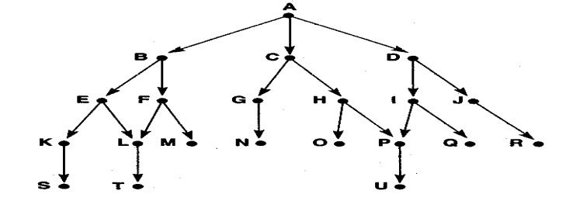
Write and trace the algorithms of Depth-first and Breadth-First search by using this graph.

Good Luck

